**DAILY ONLINE ACTIVITIES SUMMARY**

|  |  |  |  |  |  |  |  |  |
| --- | --- | --- | --- | --- | --- | --- | --- | --- |
| **Date:** | 31/05/2020 | | | | | **Name:** | RIYA C.P | |
| **Sem & Sec** | IV Sem & B section | | | | | **USN:** | 4AL18CS070 | |
| **Online Test Summary** | | | | | | | | |
| **Subject** | | **-** | | | | | | |
| **Max. Marks** | | **30** | | **Score** | | | **-** | |
| **Certification Course Summary** | | | | | | | | |
| **Course** | Cloud Foundations | | | | | | | |
| **Certificate Provider** | | | Greatlearning academy | | **Duration** | | | 4.5 hours |
| **Coding Challenges** | | | | | | | | |
| **Problem Statement1:** Write a Java program to calculate npr. | | | | | | | | |
| **Status:** Executed | | | | | | | | |
| **Uploaded the report in Github** | | | | | YES | | | |
| **If yes Repository name** | | | | | Lockdown-coding | | | |
| **Uploaded the report in slack** | | | | | YES | | | |

Online Test Summary: No internals conducted today.

**Online Certification Course Summary:** In today’s session I have learnt about classical enterprises and why cloud and Evolution of cloud. And I also came to know about Series models, Abstraction levels and SPIDERS.

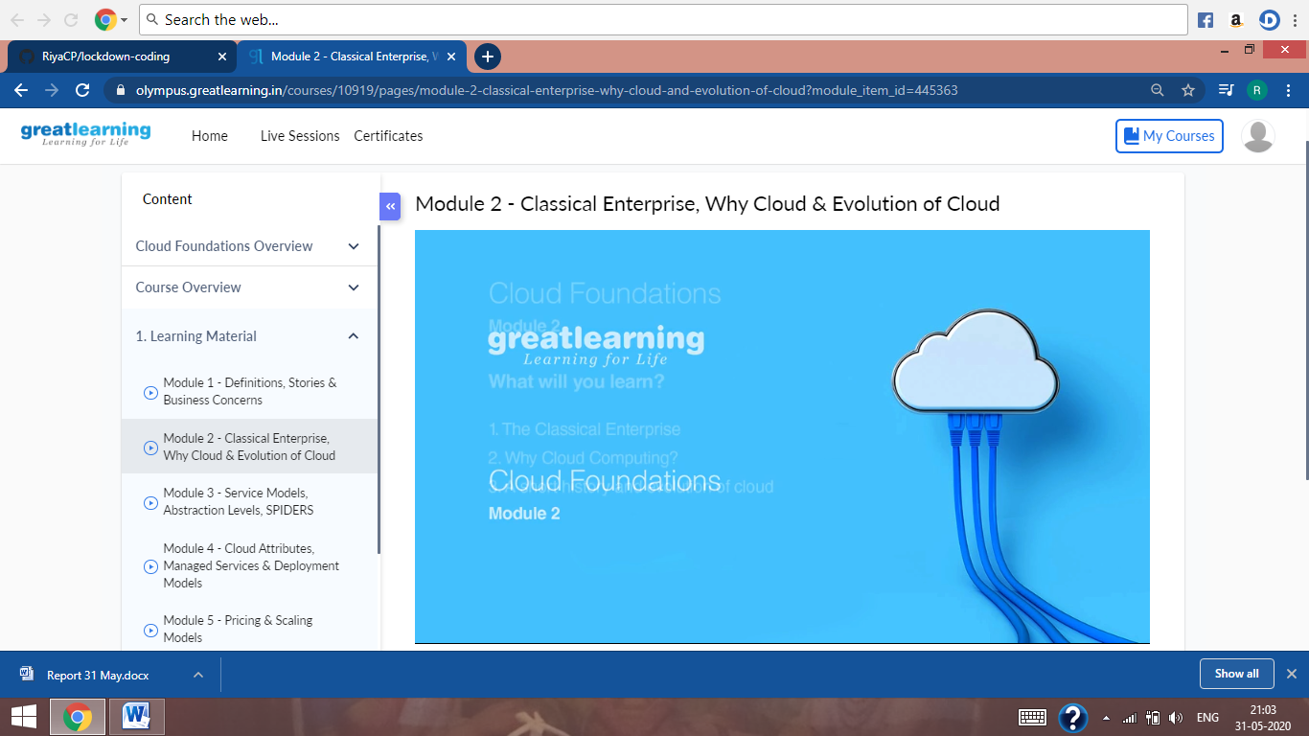

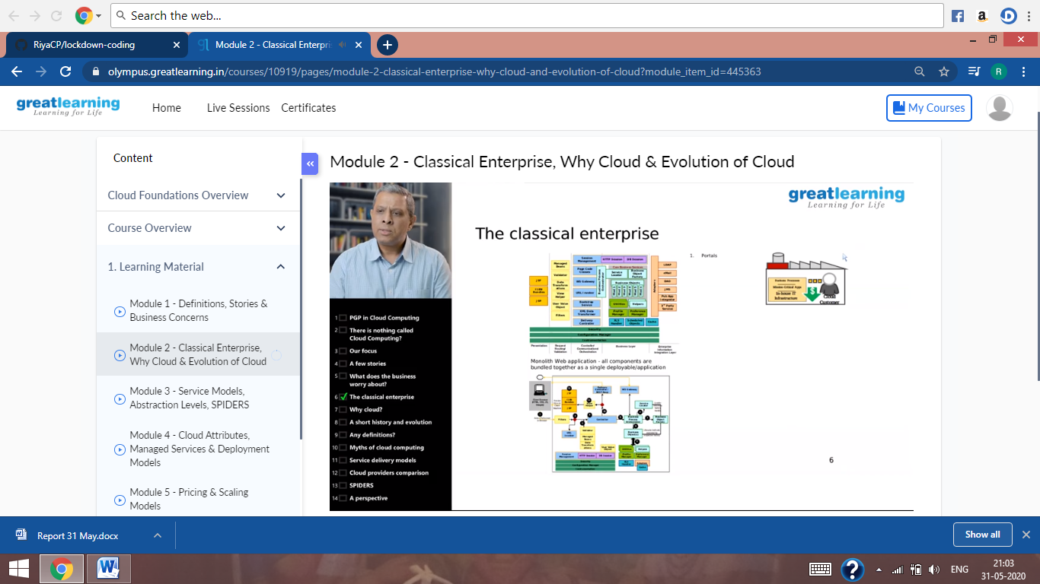

These are the Snap shots of today’s sessions.

**Online Coding Summary**: Today I had received one program from prof. Shilpa CSE Dept. The program is mentioned above in the coding challenges (pg.01). I have also uploaded it to my Github repository.

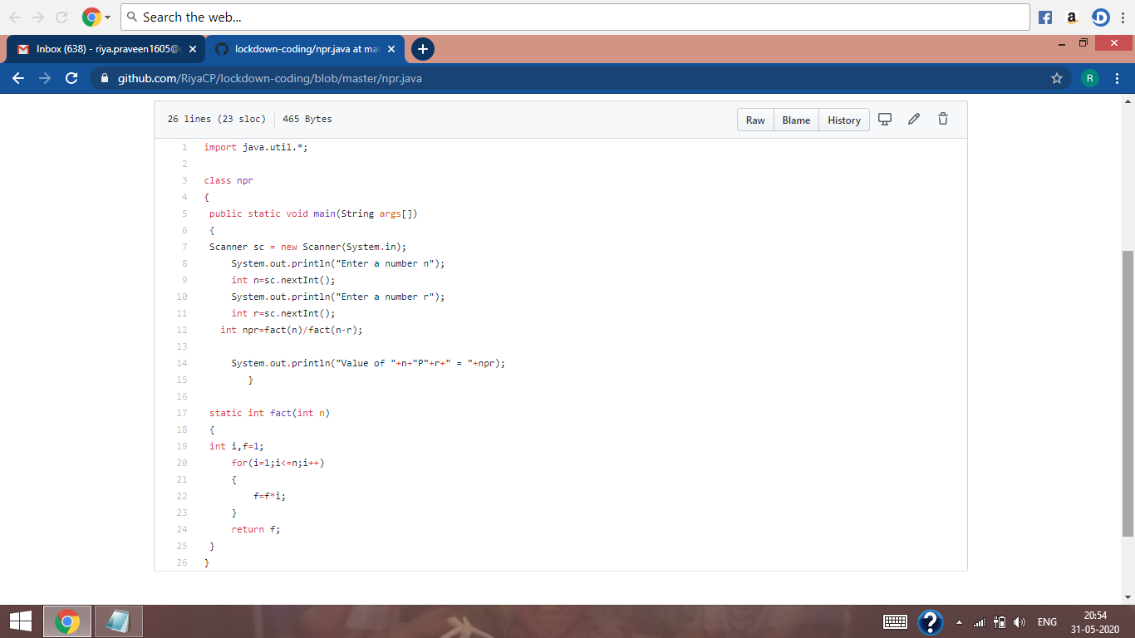

This is the snap shot of my Github repository were I have uploaded the code. File name is npr.java